Habitat committee
Majority of this committee discussed and went through the BOEM (bureau of Ocean Energy Management) projects in the GOM (Gulf of Mexico) for renewable wind energy. There’s a big push right now to create windfarms in the GOM. They are currently leaning towards placing them off SE Louisiana and NE Texas coast lines. They will be around 1 mile apart and could be built in a variety of formations with lines connecting them and then connecting them all to shore. They typically will have a buffer zone around them for construction but once open and operating they would typically enable fisherman to go right up to them to fish the structures. However, this is controlled by the USCG in most cases as BOEM does not have the ability or authority to restrict movements of vessels on the water. Here's the timeline for the BOEM project below, there’s a lot of work to be done before they ever start construction in the gulf and the council is being extremely cautious to try their best to prevent these windfarms from affecting fishery uses of the resources in the GOM.

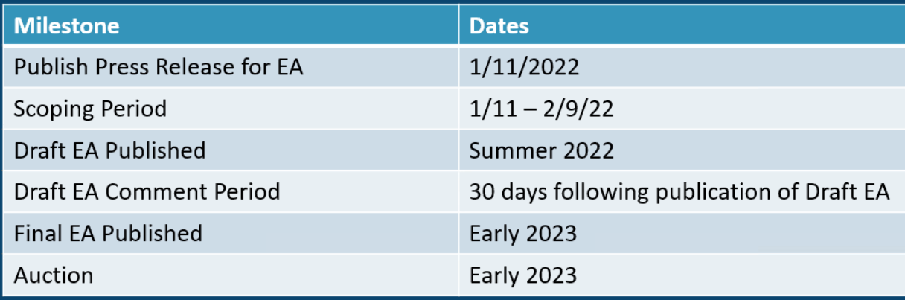

If you have questions about the BOEM projects and research in the gulf here’s the contact list for the BOEM staff working on the GOM project

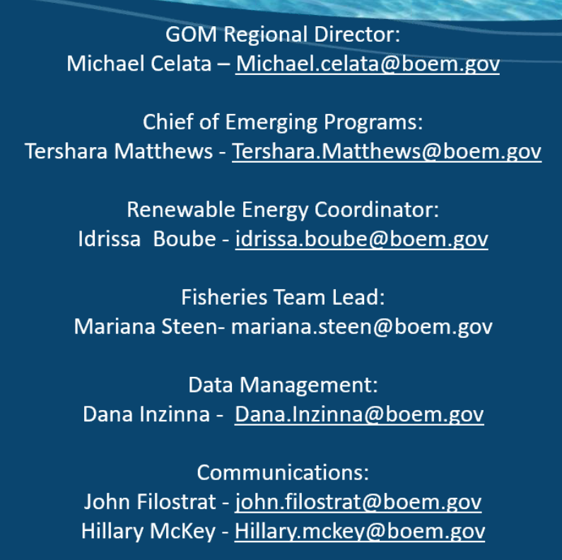

Next on the agenda was the Outreach and education committee and they spent their time review the communications and social media plans and 2021 results to the council. A discussion surfaced around potentially limiting people from commenting on the council’s social media so it would only be a place they would post things and you wouldn’t be able to respond or comment. This was due to the confusion a lot of people have that this is a place to make comments on issues. Too often people think that if they comment on the council’s social media then the council members will somehow see this and consider their opinions, which is not true. You must actually make a public comment on the council’s public comment forms for each issue. The council’s website has a place that shows all the current issues and documents they are working which are either amendments or frameworks and at this page you can comment on each item as its being drafted, ready for public comment and right before going final. Here’s that page on the council website -> https://gulfcouncil.org/amendments-under-development/ the best time to comment is when its under draft/scoping or public hearing. Once final action its less likely that comments would influence the documents greatly. Rule making means the council has already finalized the plan and its at NOAA waiting for the agency to implement the new rules established by the council.
Also, some on the council wanted to remove the ability to comment on social media due to the negativity and comments that don’t add to the constructive conversation. Many of which are poorly informed. However, the gulf council staff and myself as chair of the outreach and educational technical committee oppose turning off the ability of people to post to the council social media and the staff plead a good case illustrating why this would be a mistake. I simply said it was a mistake and pointed to the points made by council staff.

Next came the shrimp committee where they are really focused on and working towards a plan to replace the outdated cELBs or shrimp effort data. They were using a 3g cellular system to log their location points and then that was submitted to nmfs via an outdated mode of transmission. Now they are currently pulling their memory cards from these machines and mailing them to nmfs while they work on coming up with a new system to replace the outmoded shrimp cELBs.
Lots of contention surrounding vms vs elb and whether or not this info is effort data or location data

Next came mackerel committee where they discussed AM 33 on king mackerel (gulf group), reviewed CMP landings and AM 34 on king mackerel (Atlantic group). Big thing they are trying to do is update the catch levels for kingfish and increase them. Then also there’s an action that would potentially move uncaught quota from recs to comm sector. The last few years the rec sector has never even been close to the quota while the comm sector is nearly hitting their quota annually. This is the reason behind the discussion, but its very contentious and discussions are not going very smoothly. Here’s a table showing rec landings and how many of those caught fish are intentionally released. Discussion is that rec fisherman do catch and release directed trips for kingfish and that’s why the quota isn’t being hit.

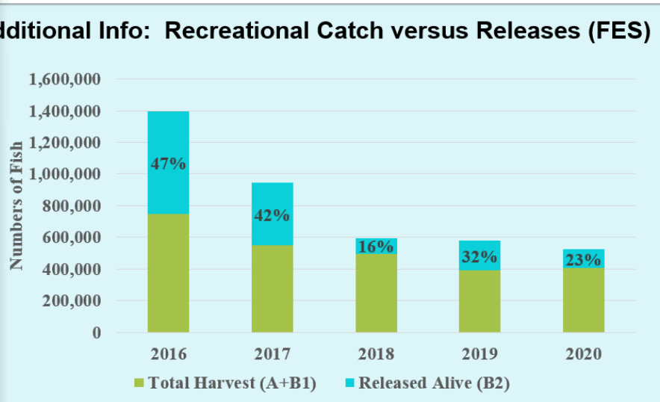

There were some more discussions over the south Atlantic document and their discussions over potentially allowing for mutilated kingfish to be landed legally. Right now, its illegal to land any mutilated fish so if you pull up a 40lb kingfish that’s bitten by a shark even if the remaining piece is legal sized you can’t keep it. However, they are trying to make it legal to land mutilated kingfish in the south Atlantic document.
Then came reef fish committee which is the largest committee with the bulk of the meeting discussions surrounded. First part of the committee they talked about reef fish landings. They discussed how they have some stocks that are going to be monitored and landings ‘projected’ in 2022 due to the accountability measures. There’s some species like cubera snapper, jacks complex, mid water snapper complex and a few others that are considered ‘data poor’ meaning they don’t have stock assessments for these species or much info at all. Due to this, they have these quotas set based on a generic amendment that was done back 8-10 years ago that took an average of landings of these data poor species to set quotas. They did say at the last meeting that the agency will be looking into updating some of these quotas based on new landings, but they haven’t done so yet. Due to that, some of these species specifically the three I mentioned cubera snapper, jacks complex, mid water snapper complex all hit their quotas in 2021 so due to that the generic accountability measure is that the following year the agency must ‘project’ landings and make assumptions on when they feel quota would be met and then do an in season ‘acl closure’ so there’s a high potential for closures in 2022 for these species.
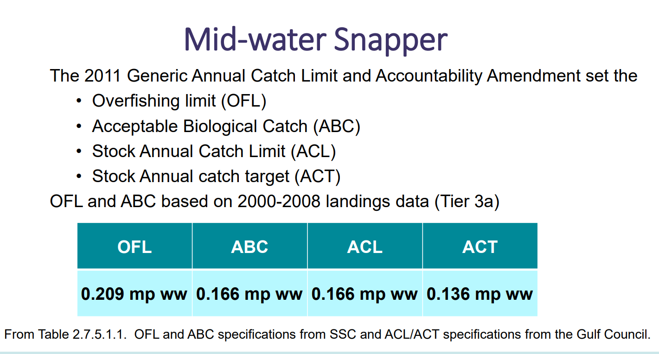
Then came the reef fish committee discussion over vermillion snapper. They are pushing for an increase on vermillion snapper catch levels which would increase the vermillions snapper quotas. They are finalizing that document at this meeting. There were a lot of discussions over the MRIP FES data and what the appropriate increase would be. The committee did review the reef fish AP motions and adopted the reef fish AP suggested alternative addition of setting the quota higher but a little more conservatively based on reservations surrounding the MRIP FES data and this is a healthy fishery, so the overall feeling is don’t increase the quotas so dramatically to potentially endanger a very healthy fishery. Good news is that there are record numbers of recruits to the fishery meaning lots of healthy young fish should be entering the fishery.
Then came the reef fish committee discussion over sedar 70 which was the greater amberjack stock assessment. The results are bleak, and the fishery has been considered overfished and undergoing overfishing for a long time and the council has attempted a few times different management measures and quotas to try and turn this around without success. There are some new research projects in the works now trying to figure out why we are not seeing new recruits and why the recruitment remains so low. There are some ideas that the sargassum weed density in the gulf ties to the health of amberjack recruitment if we don’t have the sargassum this could potentially be why we aren’t seeing good recruitment, but the research is ongoing. There’s also the great amberjack count going on similar to the great red snapper count but on a much smaller scale and it also includes the south Atlantic which the great red snapper count or GRSC didn’t.
Essentially, we are looking at an extreme reduction in GAJ (greater amberjack) quotas and access while this fishery hopefully makes some positive movement. They have initiated work on a plan amendment which is a HUGE undertaking and will take likely all year to do if not into 2023 where quotas, allocation, and management measures will be evaluated and potentially dramatically changed. I wouldn’t be surprised if we see a season measured in days or weeks instead of months for 2023 or 2024.
Then came the reef fish committee discussion over sedar 72 which was for gag grouper. Like amberjack this isn’t good. There are big concerns over the spatial sexual distribution. Which means there’s too few males for the females. There’s around 2-7% ratio of males to females where it should be closer to 20-30%. Gags are females and then transition to males later in life when needed. There’s a lot of research on going on what causes some to do this. There’s a handful of big male ‘rusty belly’ gags out there and there’s concern that fisherman, divers, and others are removing the males at such a high rate the population can’t keep up. The big males are more territorial and hang in certain areas and get that dark black ‘rusty’ belly look.
Essentially, they are going to start initiating a plan amendment for these guys like the GAJ that will evaluate a suite of options to start a rebuilding plan to rebuild the fishery. They also talked about how they could potentially pass an interim or emergency rule from the agency to reduce gag grouper quotas in 2023 while they finish work on this amendment which is very likely not to happen until mid-2023 since its just starting while the amberjack plan amendment has already at least been started. However, like the jacks we could see a season on gags that would also be measured in days or weeks instead of months and our big push will be hopefully setting this late as possible in the year like nov 1st start or dec 1st
We did get some good news on gags during full council review of reef fish committee so keep reading!
Then came a discussion on the ifq focus group. This is an effort to create a focus group to tackle the am 36 dilemma the council has been working on for more than 5 years. This group was supposed to be populated at this meeting in a closed session, but they failed to populate it as they ran out of time discussing the focus group make up.
There was some more discussion over IFQ programs (this is all commercial fishery related)
Then a discussion on wenchman occurred, this is a lesser-known species that is a part of the mid water snapper complex. These guys are being caught like crazy by some trawl fisherman in the northern gulf who are fishing for butterfish and big eye scad. Instead of catching their intended species they are catching tens of thousands of lbs of these wenchman snapper and trying to avoid them but can’t. Due to that, they are single handedly closing the mid water snapper complex and that’s causing issues for those targeting silk snapper and queen snapper. The discussion surrounded how they needed to do something about this and have more data on wenchman and investigate possibly trying to do an assessment or something more on these guys. They want to have the few fishermen catching them and the SSC get together and try to get some updated information and data to potentially ease some issues surrounding this fishery and shutting down so early. The fisherman state they actively avoid wenchman and could close the entire gulf mid water snapper complex in a just a few months if they don’t work hard to avoid them.
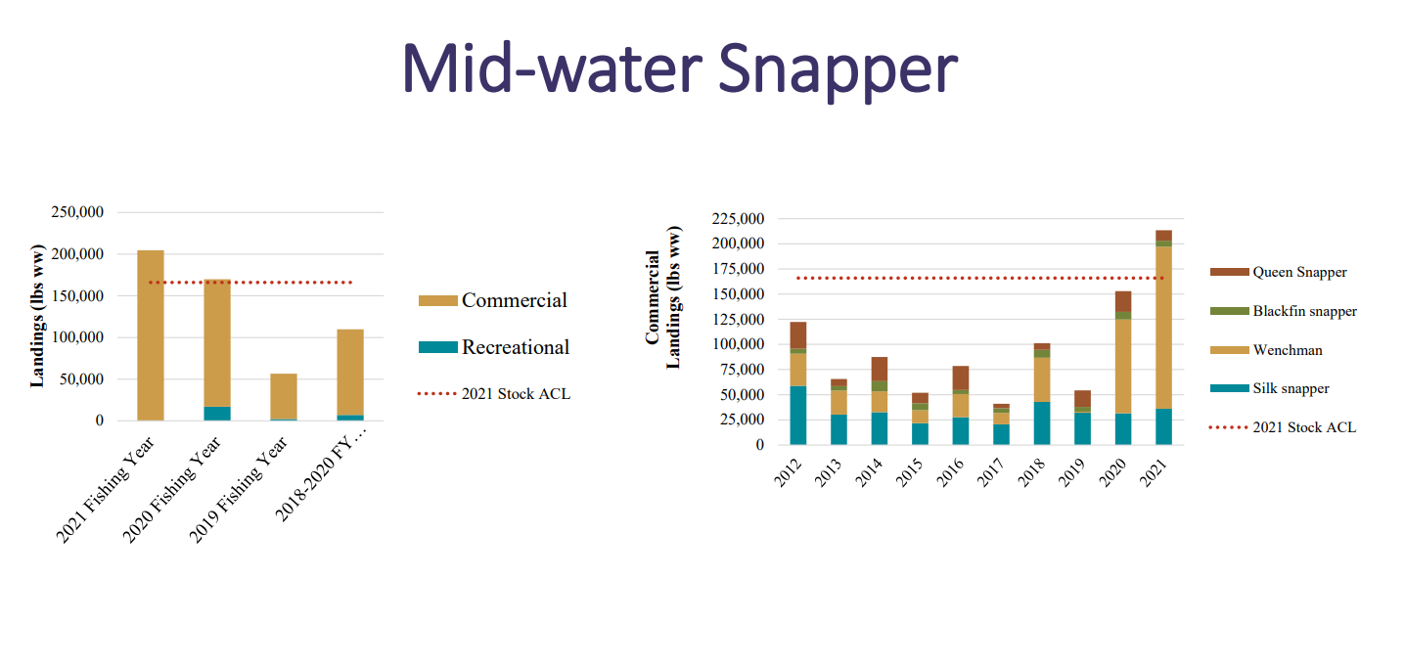
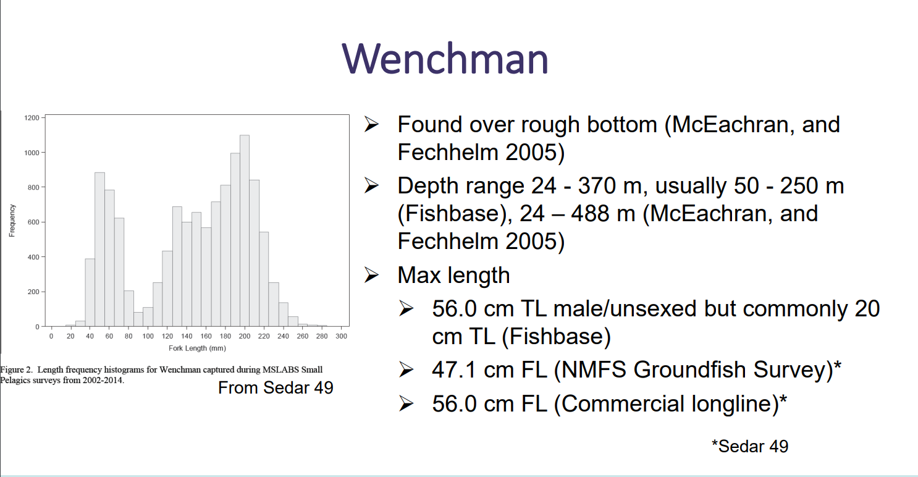
Then a reef fish discussion over the great red snapper count. The big issue surrounds how this is such a big project with so many new forms of study and approaches its going through the typical paces to try and make sure it can be turned into catch advice. Right now, the SSC still has some questions and wants more time to review so essentially nothing is happening with the GRSC data until it completes its SSC review.
After reef fish committee the data collection committee started and their main agenda was the modifications to the location reporting requirements for the for-hire vessels. This is the document that would allow for charter boats to still run trips if they were having VMS issues in the sefhier program once the phase 2 rollout is completed. Unfortunately, the council made a big change in their thinking and the committee decided to push forward with only allowing a 10 day exemption if your VMS isn’t function instead of the 14 days they discussed last meeting. Also, they cut the number of exemptions you could get from 3 down to 2 per year. They also discussed how they would look at this again after a year or so after it was implemented to see if it needed to be re evaluated based on how much its used or needed and observed VMS failure rates.
The data collection committee also discussed the updates to the commercial electronic log book programs and how they are trying to move to an even more real time reporting for the trip log books. This would be in addition to the hail out, hail in, trip tickets and observer programs as well.
Then the data collection committee had a sefhier update to see observed compliance and use of the program so far across the south east which includes the south Atlantic. They discussed some options that could potentially solve the duplicate reporting issue, but nothing was moved forward.
THEN FULL COUNCIL BEGAN ONCE COMMITTEE DISCUSSIONS CONCLUDED…
Sometimes during full council the committee discussions are concluded, changed, or votes can occur to add to the committee discussions

Big thing in mackerel was that they voted to split the alternatives in am 33 and separate the discussions over altering catch levels higher an the discussion over allocation into two different documents
The full council also moved forward on allowing the south Atlantic kingfish document to include the portion about allowing for landing legally shark bitten kingfish if the chunk left over was legal size (this was in Atlantic document only!)
For data collection, at full council there was another discussion of multiple hail out issue… the agency is going to try to work with council to edit the definition of a trip that would hopefully solve the duplicate hail out issue.
**We are working to set up a meeting with the agency to fully vette this idea out and ensure we do what we can to solve this issue
For reef fish the full council finalized the reef fish ap motion of a conservative increase to catch level increase for vermillion snapper which was a newly added alternative. The full council also voted to bring this document final.
The reef fish full council discussion also had a HUGE CHANGE on gags. The RA asked the SEFSC to do an update on landings for gags for the past few years and include that as possible interim analyses and include as an update to sedar 72 for gags. This was based on public comments and lots of emails, texts and calls about how the gag grouper fishery is cyclical and we are seeing a little bump in the gag numbers last two years. The science always lags behind management and this is an attempt to help bridge that gap which is huge!!! This could potentially lessen the blow we could see on gag grouper management
Then also on reef fish, they voted to move forward on getting the SSC and fisherman together on wenchman snapper to look more closely at this fishery and the issues we are seeing in mid water snapper
Then one big thing I saw was a NOAA OLE (office of law enforcement) update on their recent efforts in the gulf. They presented they caught someone who was running an illegal charter without a permit and only got a 24K fine when the permit cost is 30K or more… due to this it spurred the letter below…
This concluded the meeting, please read meeting notes below this letter if you want more finer details on the meeting and what occurred!
---------------------------------------
Letter to council I sent after listening to end of meeting NOAA OLE report….

Gulf of Mexico Fishery management council members and staff,

Upon listening to the end of today’s council meeting, specifically the NOAA supporting agency report, I feel it’s extremely germane and important that the council pursues writing a letter to SERO with the intent of reaching NOAA’s GC and their assessment schedule issues as it relates to the council and the council processes. Today’s meeting following a council member’s comments it was made clear that the council and council process does not have the ability nor authority to dictate or even impact the summary schedule listed at this URL -> https://www.gc.noaa.gov/gces/2019/SE-SSS-Final-6-27-19.pdf

This URL shows that the penalty for fishing without a moratorium permit, only when permit was never issued the fine is only $3,00 when the reef fish permit for the for-hire fishery for an entry level low level six pack permit is now $30,000 is extremely outdated.

When caught fishing with an expired permit the summary schedule only denotes a $750 fine for fishing with expired moratorium permits as well.

I highly encourage the council to write a letter to SERO that would inspire, encourage, and really engage their general counsel to raise their schedule of fines for fishing without a moratorium permit to be more in line with the cost of the actual permit.

If our goal is to discourage fishing without moratorium permits, then the fee schedule should be at least double if not triple commiserate with the going rate of that moratorium permit the angler is found fishing without. Especially when considering the time and tax dollars it takes NOAA OLE to build and make a case to be presented to NOAA general counsel.

Keep in mind, as a fisherman if we are out on the water and run across a known illegal operator we can film the boat, operator, gps and registration number of that vessel in a single video unedited and forward to our state enforcement, NOAA OLE and USCG and nothing will happen as we are not deputized individuals. This will only earmark that vessel and operator as someone they should look at, then investigators, and enforcement must get involved, build, and make a case which takes extreme time, dollars, and effort.

That case is then forwarded to the office of NOAA GC only to have a fine levied of less the cost of the actual permit. When trying to institute management measures like the sefhier program and you threaten the ability of operators to renew their permits that doesn’t have teeth with schedules as they stand. Why not let your permits lapse? If you are found to be operating without renewed permits if your turned in, if they build a case, if it makes it to court without you renewing those permits your fine would only be $750 according to current fee schedules as outline by NOAA office of GC.

I feel strongly that if the council would like to de-incentivize illegal fishing in the EEZ by unpermitted operators that operate without a federal moratorium permit in the EEZ in the GOM their fee schedule should be at least commiserate with the permit cost x2 if not exponentially higher.

If you know you can make money for months and only incur the fine of less the cost of operating legally then what incentive is there to operate legally? You wouldn’t have to have turtle gear or operate in the sefhier program not only saving permit costs but also the costs of the sefhier program.

Our industry would like to improve our data, accessibility, sustainability and accountability and we can’t do that without your help to reach out to the SERO office to encourage them to significantly increase the fine schedule for those found operating charters without the proper moratorium permits required to operate legally.

Illegal charters are rampant across the GOM we saw discussions and issues over IUU fishing, and I would argue that the domestic illegal charter operations rival if not exceed those efforts in our EEZ annually.

Thank you for your time and consideration,
Capt Dylan Hubbard
---------------------------------------
MEETING NOTES

Gulf of Mexico fishery management council meeting
Jan 24th through Jan 27th 2022
VIRTUAL ONLY – was scheduled for Baton Rouge, LA

MONDAY Jan 24th

HABITAT COMMITTEE – habitat protection and restoration
- Presentation from BOEM (bureau of ocean energy management) on wind energy development in the GOM
  - Presentation on BOEM process
  - Turbines are 65-100ft from surface of the gulf
  - New tech could be 200ft from surface
  - BOEM does not have authority to restrict vessel traffic or activity
  - Cables will be buried 3-10ft in waters shallower than 6,562ft
  - Burial depths could vary based on projects
  - Wind farms have life span of around 30 years then removed
  - No federal fisheries contingency fund for renewable energy
  - EA – Environmental Assessment
  - EA focuses on issuing leases and lease sites
  - SW LA and along TX coast likely
  - **Timeline & contacts for BOEM in folder
  - Discussion from committee
    - Question about buffers for turbines
      - Current projects have buffer for construction
      - Buffer removed once construction completed
      - Likely like oil and gas how you can get up to them, but not tie up
    - Recommendation about fisheries contingency fund
      - Centralized fund
      - All operators should contribute
      - Like oil and gas industry
  - Shrimp AP comments on BOEM project
    - Questions about updates to council and council input
    - Request to have shrimp industry reps be added to task force for BOEM
- Generic EFH amendment for modifying all GOM management plans
  - Required to know EFH for all life stages of each of the species in the FMP
  - Forty species included in document only enough info to do 7 of those species in alt 3 or 4
  - Lots of discussions around EFH and what is EFH and how detailed council wants to get
  - Biggest confusion is over alt 3 & 4 and their technicalities
- Draft response letter to EO 14008 – 30 by 30 order – closing 30% of land and sea for conservation by 2030
  - No discussion looking for motion to approve draft
  - Motion raised to approve – will move to final council for final approval

Committee motions –
Motion to include COMPLETE historical gulf shrimp effort in spatial management analyses for evaluating potential sites for BOEM/NOAA – passed committee
Motion to request the council work with nmfs to ensure BOEM works with NOAA on ESA interactions early in BOEM process – passed committee
Motion to move forward draft response letter on EO 140008 to full council for approval – passed committee

FULL COUNCIL SESSION
**note** Dr. Shipp’s wife passed he isn’t present for council meeting due to that
Election of council Vice Chair to fill martha’s voided role as vice chair
- Greg stunz nominated
- Bob gill nominated
- Greg stunz elected as vice chair of the council
New council committee assignments to fill martha’s void - frazer now chair of reef fish and Dyskow for lobster

Outreach and educational tech committee
- presentation 2021 communication analytics and updated 2021 communications improvement plan
  - comm fish rules is bad to the bone with lots of users, high use time and frequent use
  - open rate 33-35% for emails
  - haven’t made any videos yet
  - youtube video views still climbing
  - facebook steadily increasing
- draft social media guidelines
  - why to start accounts
  - content guidance
  - deleting posts, comments guidance
  - discussion on negativity
  - BIG PUSH it seems to shut off ability to comment on council posts by dr. stunz
- draft public comment guidelines
  - no discussion over these
- draft press release guidelines
  - when they are sent
  - why they are sent
- 2022 communications improvement plan
  - Discussion of document and proposals
  - Push towards video outreach
- Remaining items from O&E tech committee
  - I presented here, couldn’t take notes but essentially reviewed AP report
- Presentation – summary of discard and barotrauma reduction efforts across region
  - Illustrated three ccurrent projects in the works
  - Descend act
  - Return em right

Shrimp Committee
- NMFS evaluation of draft approval specs for reinstituting historical cELB program
  - A lot of cost involved
  - Cloud server needed with OLE access
  - Need vms tech specs modified
  - Essentially a walk through of the changes needed
  - 2 way communication is needed, cant change national vms rules it seems
  - Big discussion over next steps
- Updated draft framework: modification of the vessel position data collection program for GOM shrimp
  - Big question in action 1 is naming of unit description VMS vs ELB
  - Seems there’s been an issue getting industry to volunteer to test units for program change
  - Lots of back and forth over terminology still
- Summary of shrimp AP meeting
  - Going through AP summary from briefing book
  - BOEM motions seem controversial

MACKEREL COMMITTEE
- Review of CMP landings
  - https://gulfcouncil.org/wp-content/uploads/C-4-ACL-Updates-CMP-to-Gulf-Council_Jan-2022.pdf
- Draft AM 33 – modifications to GOM group king mackerel catch limits and sector allocations
  - Review of how CHTS to FES compared with percent change
  - Historically comm sector landing its ACL while REC is pretty far from the ACL
  - Discussion of re allocating fish back to comm sector
  - Discussion of modes of prosecution – gillnet fleet landings are exponential
  - Removed some alternatives from document to prevent rec overfishing if re allocation occurs
- Draft AM 34 – Atlantic group king mackerel catch levels and Atlantic king and Spanish mackerel management measures

- Other business

REEF FISH COMMITTEE
- Reef fish landings - https://gulfcouncil.org/wp-content/uploads/B-4a-GMFMC_Jan22_Reef-Fish-Landings.pdf
  - Cubera may have a closer in 2022 due to quota monitoring
  - Mid water snapper may also have 2022 closersure for same reason
  - Jacks complex too – mostly almaco landings comm and lesser in rec
  - Comm IFQ landings for gags and red grouper both up over last year
  - Discussion over private rec state managed red snapper landings – should be included in landings
- FINAL ACTION – framework action: modifications of vermilion snapper catch limits
  - Questions from reef fish ap about increase, hard to know what increase looked like without comparing fes data to fes data
  - Seems they are considering following reef fish AP motion of adding alt 4 of a more conservative approach
  - Alternative 4 has been added – added without opposition
  - Discussions now over preferred alternative changing seems being conservative is new council approach
  - NEW alt 4 is more conservative option than alt 3
  - No new preferred picked at committee
- Sedar 70 – greater amberjack projections
  - Talking about SSC recommendations
  - Allocation scenarios can alter yield around 5%
  - ABC recommendations are extremely lowered from OFL like 75% reduced to start
  - Generally, as more fish go to rec then OFL and ABC are reduced slightly
  - Motion made to request discard data on gags, red grouper, amberjack and red snapper based on reef fish ap motion
  - Motion made about GAJ rebuilding plan – revising it to match reef fish ap motion
  - This motion was rescinded
  - Lots of discussion over new SSC recommendations
  - Have to start from square one on rebuilding plan
- Sedar 72 – gag grouper projections
  - Want to move to MSY proxy from Fmax to F30%spr as recommended by the SSC
  - Initiating plan amendment to address a rebuilding plan for gag grouper and to adopt new proxy
  - Initiating a interim rule or emergency rule by NOAA to lower gag catch levels for start of 2023 until rebuilding plan amendment can be constructed
  - Motion about SRFS data calibrating with MRIP FES – motion carried
  - Essentially ultimate decision pushed to full council
- IFQ focus group
  - Member positions (1 of each except shareholder – 3 of those)
    - Dealer
    - Crew with no shares
    - Permit holder who leases allocation
    - Eastern gulf long liner who leases ARS allocation
    - Share holder positions (3)
      - Small – lower third of shareholdings
      - Medium – middle third of shareholdings
      - Large – top third of shareholdings
    - Public participant
    - New entrant
    - Knowledgeable person, not financially invested
  - There were 57 applicants for 10 positions
  - Noticed on council website and press release
  - A one and a half day meeting in tampa in person
  - May use breakout groups
  - Open to public like AP meeting
  - How many meetings is a question…
  - Ifq focus group timeline saved in folder**
- IFQ programs
  - Motion about bringing 36b final by June 2022 – but no 2nd received
  - Feeling is wait till after focus group concludes
- Discussion: Draft Snapper Grouper Amendment 44 and Reef Fish Amendment 55: Modifications to Southeastern U.S. Yellowtail Snapper Jurisdictional Allocations, Catch Limits, and South Atlantic Sector Annual Catch Limits
  - Discussion surrounding if we can get updated catch advice
  - By the time work was ready to start ssc recommendations were nearly 6 yrs old
  - Motion to stop working on this document until the FWC can conduct an update to the assessment to incorporate three more years of data and a constant catch projection to set ABC – PASSED
- Discussion – wenchman in GOM
  - Caused closure of mid water snapper in 2021
  - Generally, less than 300lbs per year are landed recreationally
  - They are mostly landed by trawls commercially 93-99% of landings
  - A lot of discussion about the one angler who’s trawling up all these wenchman snapper
  - Need more information for anything to happen
  - Discussion over an SSC presentation with the captain who catches em all with trawl
- Review of Revised Great Red Snapper Count Estimates and SSC Recommendations for Re-evaluating Red Snapper Catch Advice
  - Lots of consternation about the outcomes of the GRSC
  - Feelings are the outcome isn’t what some were looking for
  - Upset at the length of time it took to review this
  - Still questions around the outcomes and reviewing process
- Discussion of remaining SSC recommendations
- Discussion of remaining Reef fish AP motions
Reef Fish Committee motions –
For vermillion snapper – in action 1, add alternative 4 – setting ACL at 75% of the ABC
- This is basically like alt 3 but instead of 9% buffer it’s a 25% buffer
For amberjack – to direc staff to revise the current GAJ rebuilding plan by adopting Frebuild as recommended by the SSC, for the current sector allocation, and not make any other management changes to GAJ --- **This motion was rescinded
For gag grouper few big motions saved as photos
For yellowtail snapper - Motion to stop working on this document until the FWC can conduct an update to the assessment to incorporate three more years of data and a constant catch projection to set ABC – PASSED

DATA COLLECTION COMMITTEE
- Modifications to location reporting requirements for the for-hire vessels
  - Commercial vessels were removed from the document
  - Only applies to the for hire vessels
  - Dual permitted boats don’t get exemption
  - In alternative 2 – now options are 7,10 and 14 days – based on calendar days NOT business days
  - In alternative 3 – exemption numbers have not changed – still 1,2 and 3 per year
  - Alt 2 & 3 can be selected concurrently
  - Reef fish AP recommended alt 2 option 2c and alt 3 option 3c
  - Agency is opposed to allowing 14 day exemption
  - VMS data can be used for effort
  - Issue is worries over long exemptions and multiple extensions
  - MOTION TO MAKE 2C PREFERRED
  - SUBSTITUTED BY 2A – FAILED
  - VOTED ON ORIGINAL OPTION 2C – FAILED
  - MOTION ON OPTION 2B – motion passed without opposition
  - In Alt 3 motion made to make 3c preferred
  - Substituted for 3b – motion passed
  - Current council preferreds 2b and 3b – this means 10 day exemption with option for 2 exemptions
  - Noaa ole did comment on the record they would work one on one with individual circumstance
  - Seems like council wants to review this a year into program to perhaps change these or tighten these up after program is stood up
  - No public hearing on this document – just public hearing video
  - Will be going FIINAL in april gulf council meeting
- Commercial electronic log book reporting
  - Trying to cut down on duplicative reporting
  - Sharing data between science centers for dual permit holders
  - A lot of commercial permits affected by this
  - Starting slow and listening to their AP feedback (unlike sefhier plan it seems)
- Sefhier updates
  - March 1st is the gulf implementation data for phase 2
  - Discard disposition questions about why aren’t we collecting that in for hire reporting
  - Essentially no movement on colregs idea or any other ideas to mitigate duplicate reporting
  - Sero did say they will ‘look into’ exploring more options but that’s it
Data collection committee motions –
MOTION – in sefhier document – to make alternative 2c council preferred
Substitute motion made – in sefhier document – to beat out the one above to make alt 2a the preferred in alternative 2
Substitute motion failed!! Going back to original motion
MOTION – in sefhier document – In Alt 3 motion made to make 3c preferred
Substitute motion made – in sefhier document – Substituted for 3b – motion passed

SUSTAINABLE FISHERIES COMMITTEE
- Standardizing bycatch reporting methodology
  - SBRM – standardizing bycatch recording methodology
  - Includes economic and regulatory discards
  - Does not include intentional catch and release (tarpon fishing ex)
  - Doesn’t include incidental catch, not intended species caught and KEPT
  - Lots of questions on commercial discard numbers
  - More discussion over bycatch and discards
  - Council seems to want more time to discuss discards

FULL COUNCIL
- Three APs that need to be re advertised and re populated
  - Data collection
  - Spiny lobster
  - coral
- habitat committee
  - committee motions passing full council
  - shrimp industry onto boem panel
  - also, boem must consult with nmfs early as possible in process about esa interactions
  - motion added to make sure that the boem exploration includes some consideration in spatial planning in relation to user conflicts with fisheries
  - a lot of back and forth to try and protect fisheries impacts from boem project and renewable energy exploration in the gulf
- outreach and education
- special closed session (surprise)
  - they didn’t fill work group
  - they are convening a special session to complete population process
  - they didn’t have enough time essentially
  - talking about virtual special session
- outside agency updates
  - GSMFC
  - SAFMC
  - USCG
  - LDWF – 2,500 contacts with comm and rec stakeholders – IMPRESSIVE
- Mackerel committee
  - NEW - Motion to add an action to AM 33 on king mackerel to provide a bases for a Research set aside program (RSA) that develops funds for council directed research needs. The RSA program is to be developed by the council in a separate amendment
  - Motion was substituted- to request presentations of the new England and mid Atlantic RSA programs at the next council meeting – THIS MOTION PASSED 14-1
  - Sooo they aren’t starting an RSA but they are looking into possibly doing it
  - NEW – motion to remove action 1 from AM 33 and start a new framework action – basically wanting to split action 1 and action 2
  - This will speed up action 1 to modify catch levels by moving it to new framework document
  - This will leave allocation discussions in AM 33 plan amendment
  - MOTION CARRIED 9-7 – actions are being split
  - South Atlantic may have to weigh in now… due to this, lots of questions about what this does now since we had an agreement with south Atlantic council
  - Committee motion about cut off south Atlantic fish moves forward it seems, allowing mutlitated or bit off fish that are in your bag limit and comply with size limits to be landed legally
  - Motion carried – was contentious
- Data collection committee
  - Sefhier document - Committee motions completely moved forward without any discussion or opposition, public comment completely ignored essentially
  - So the vms document is leaving with preferreds of alt option 2b and alt 3 option 3b
  - So you get ten days, twice in a year only
  - Kevin anson brought up the multiple hail out issue
  - Andy is saying that we could perhaps change definition of trip, that could help cure the multiple hail out issue
  - They are going to try and change the definition of the trip to cure the issue of multiple hail outs
  - No motions are done on multiple hail out issues, just discussions
- Reef fish committee
  - For vermillion snapper, committee motion of adding an alt 4 passed without opposition
  - NEW – full council motion – made alt 4 the preferred for vermillion snapper – this was reef fish AP recommendation
  - NEW – full council motion – to make vermillion document FINAL – motion carried unanimously
  - Amberjack plan amendment in the works, draft options will be presented in April for GAJ rebuilding plan
  - Gag grouper plan amendment is in the works, motion passed to intiate it
  - GAJ plan amendment for rebuilding already in the works, we will see in April
  - The committee motion about asking the agency for an emergency rule on gags has been delayed until April gulf council meeting – they will re evaluate that ask during the next meeting
  - NEW FULL COUNCIL MOTION ON GAGS -- **huge** - To request that the SEFSC update the indices of relative abundance for gag grouper through 2021 and explore the feasibility of using those indices for an interim analysis to update ABC and OFL advice
    - This would allow them to update the stock assessment results
    - This could lessen the blow to quota cuts
  - NEW full council motion on whenchman snapper – they will be looking at early stages of possibly doing a stock assessment on these with SSS and industry in conjunction with the SEFSC
  - Lots of discussion and questions surrounding when the GRSC will be ready for catch advice
- Sustainable fisheries
- Shrimp committee
  - Lots of discussion over tech specs of new devices to replace cELB devices
  - Lots of issues around vms vs elb
- NOAA OLE update
  - 24K penalty for fishing for red snapper without a permit
  - Council talked about how low penalty was and noaa GC told them well you don’t set penalty we do…
  - Fishing without a moratorium permit is only 3K

